**Agglomerative & Divisive, Dendrograms**

Hierarchical clustering is of two types

1. Agglomerative : it is more popular technique
2. Divisive



1. Agglomerative :

Suppose we took data points as shown in below figure.

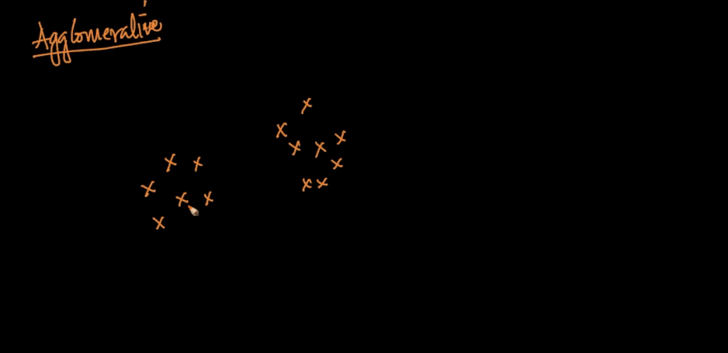

Now agglomerative initially consider each point as a cluster. Therefore there are 13 clusters in starting

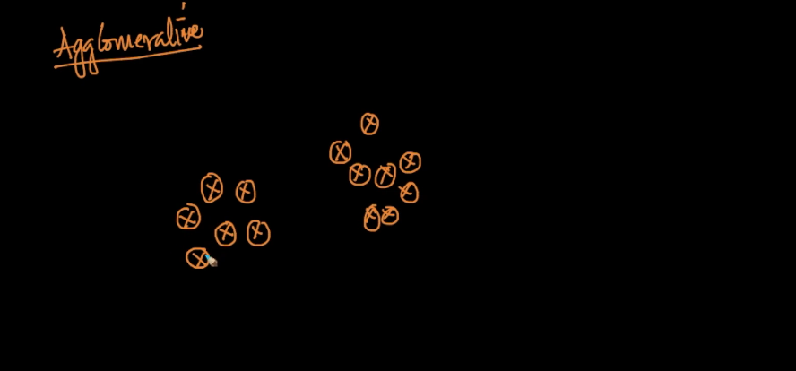

Now after considering distances or similarity it combines two or more cluster and make it one

Therefore we have only 9 clusters now.

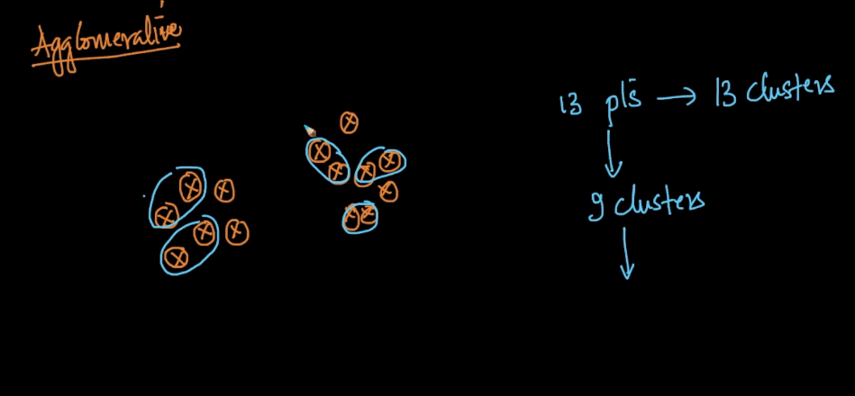

In each iteration it do same thing and generate new clusters therefore now we have 5 clusters

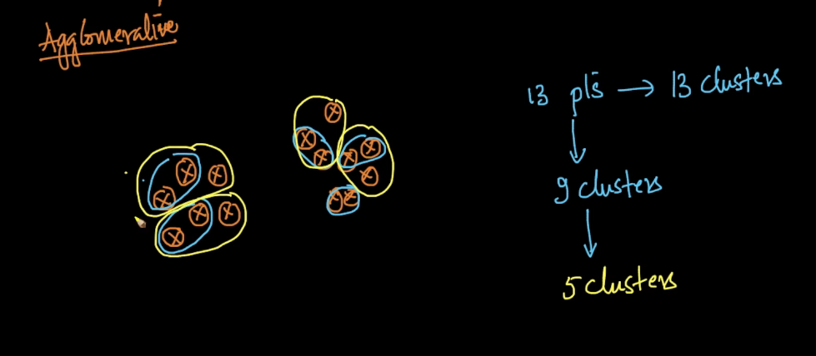

This iteration is continue till we have only 1 cluster.

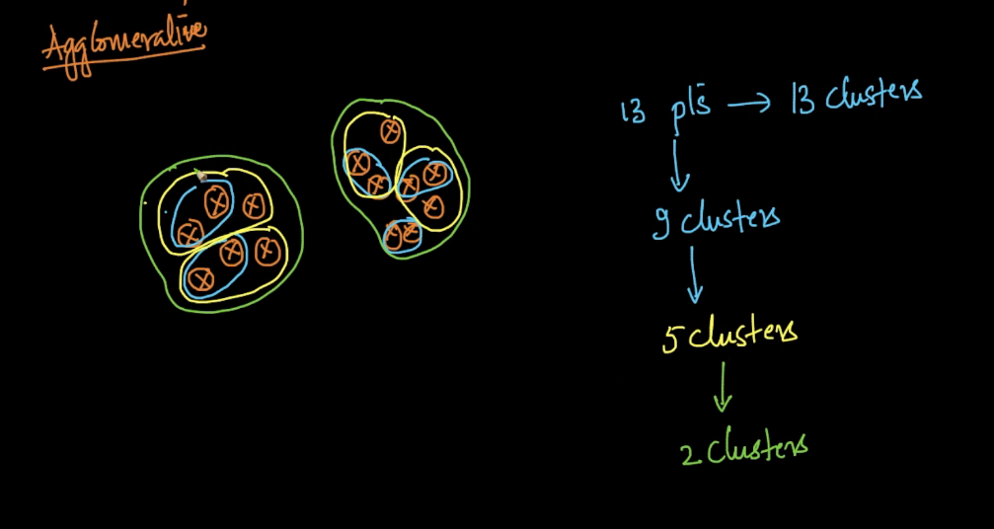

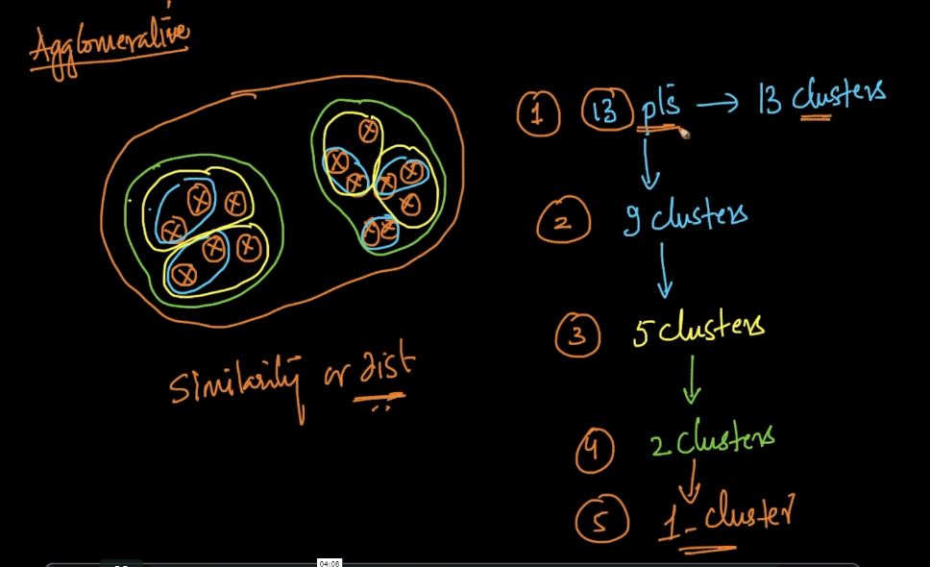

2)Divisive :

It is opposite to agglomerative technique.

In divisive initially it took all points in 1 cluster, and at each iteration it divide this cluster based on distance or similarity to form new clusters and this iteration/process continue till each points consider as a single cluster

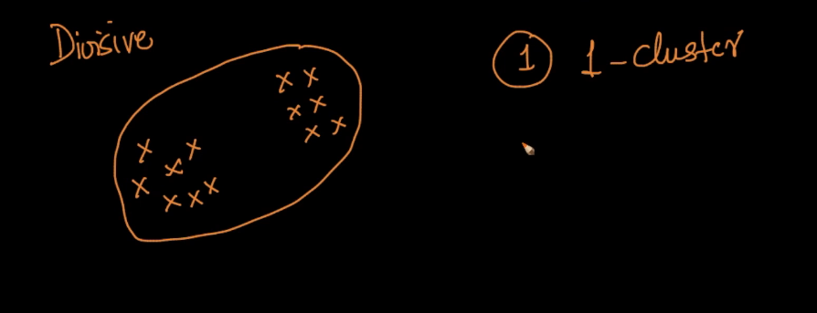

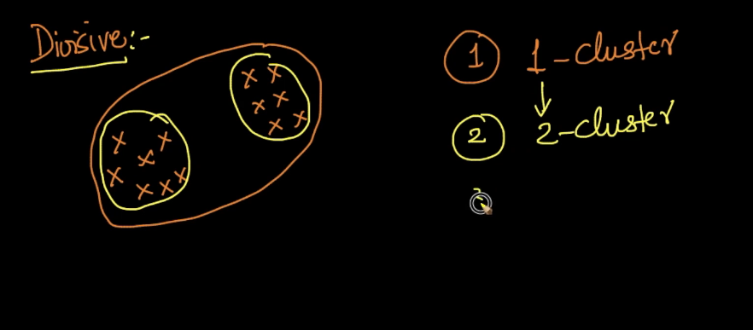

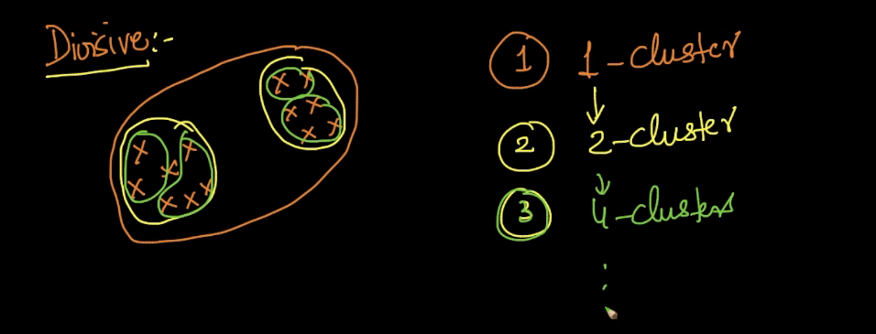

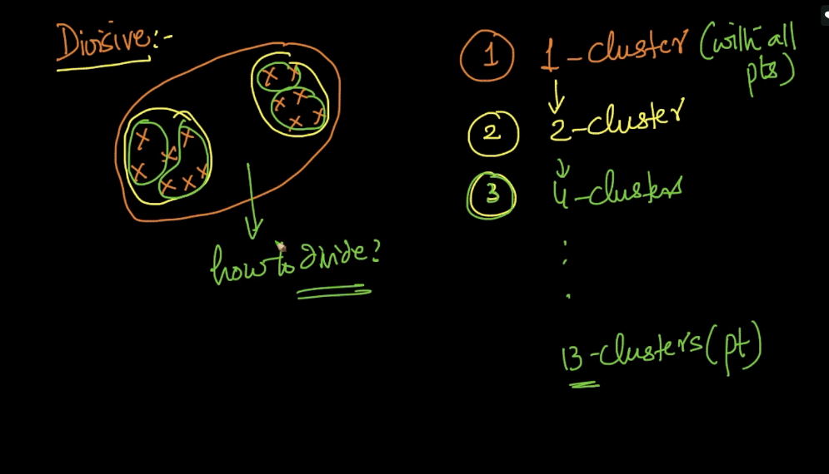

Key ingredient of agglomerative is similarity or distance between two clusters

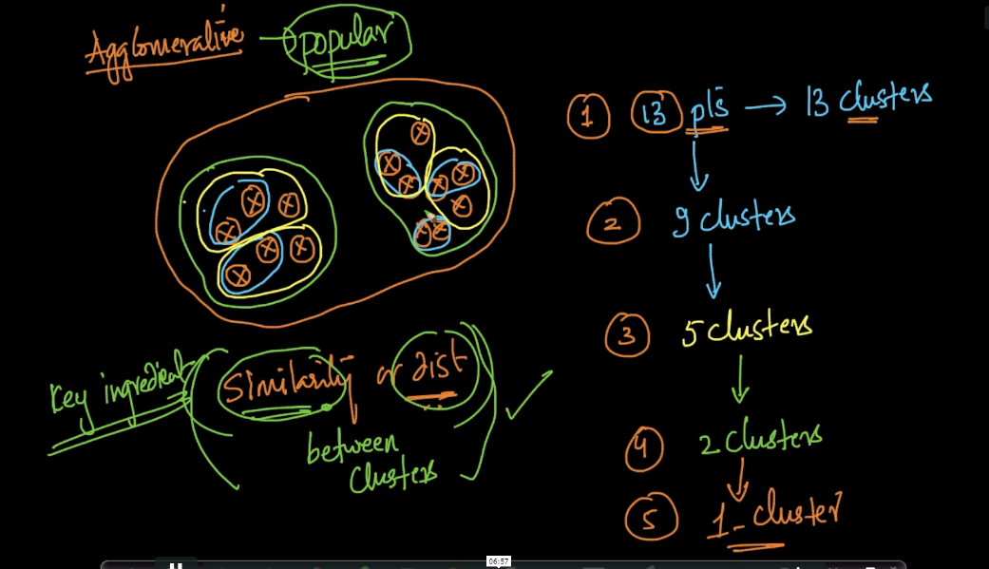

**Dendogram** :

Dendogram is a tree which records the sequence of merges(for agglomerative) and splits(for divisive) .

In this x-axis have data points and y-axis have the distance or dissimilarity between clusters.

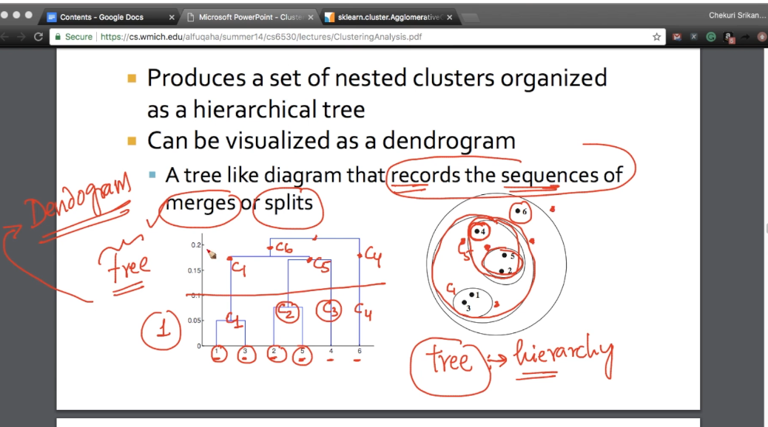

Major advantage of hierarchical technique is we don’t need to give no. of clusters or hyperparameter like we give in k-means.

We take an example of agglomerative it generates clusters from 13 to 1 cluster in one run we can take any number after running it in single time unlike K-means where we have to run model again n again to get different number of clusters.

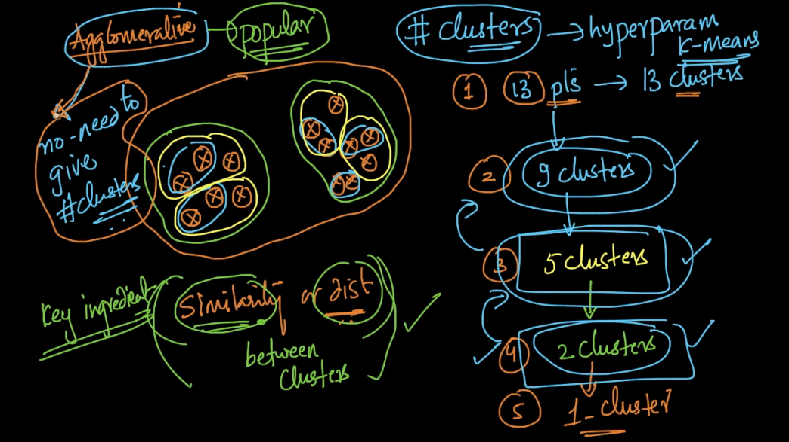

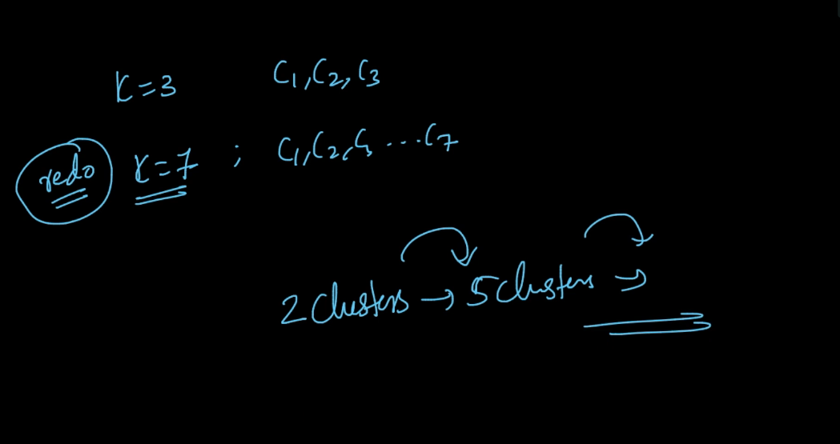

Dendogram :

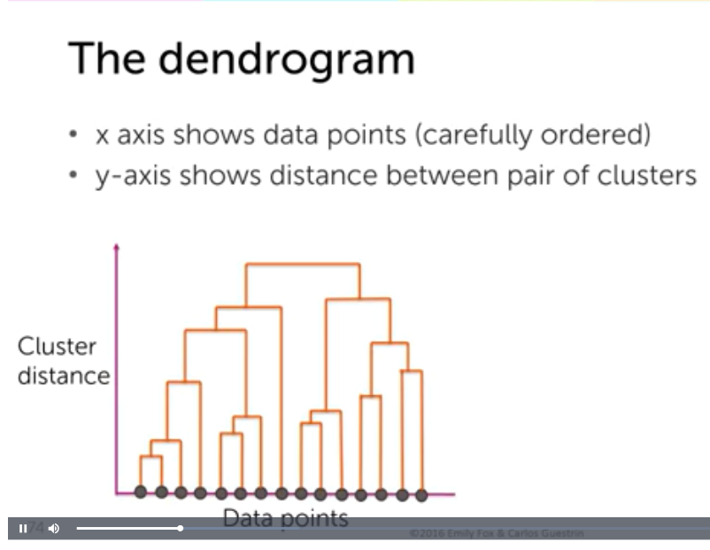

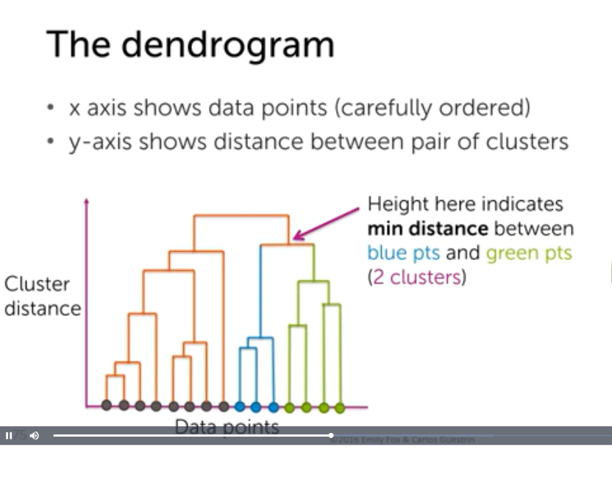

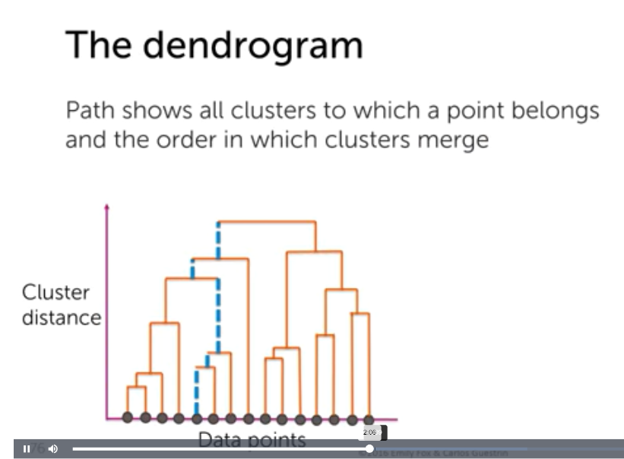

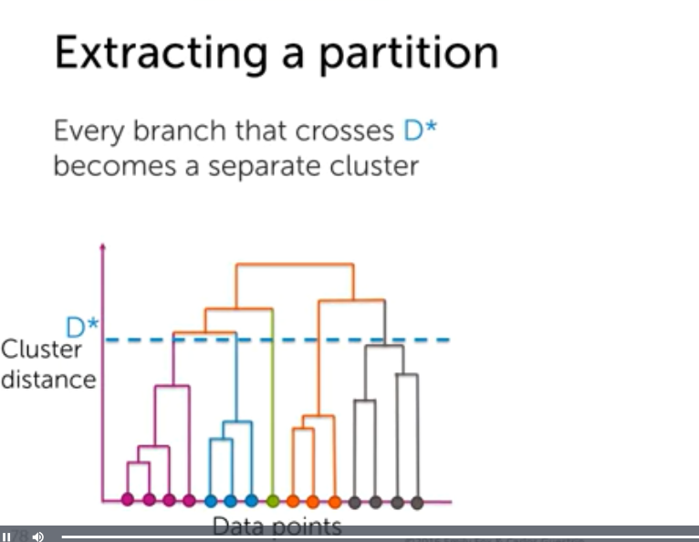

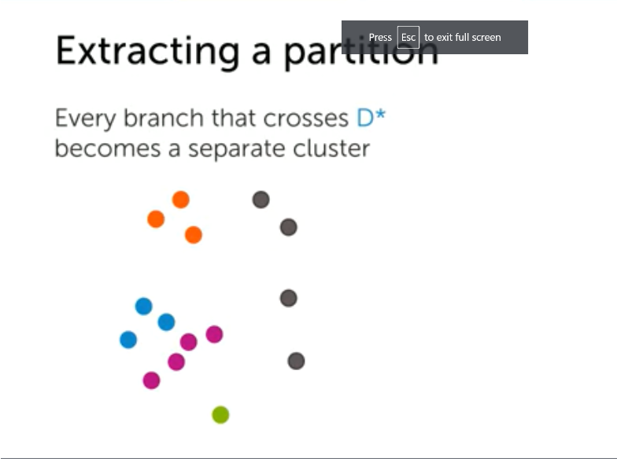

Comments :

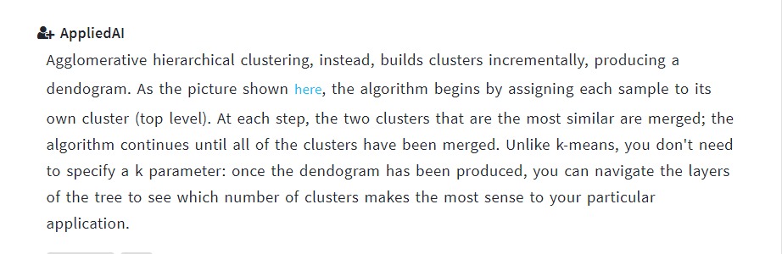

Links:

<https://pt.coursera.org/lecture/ml-clustering-and-retrieval/agglomerative-clustering-details-mFZqI>

Hierarichal clustering examples: very good read:

<https://towardsdatascience.com/hierarchical-clustering-and-its-applications-41c1ad4441a6>

showing dendrogram: <https://stackabuse.com/hierarchical-clustering-with-python-and-scikit-learn/>

when to use which metric for clustering:

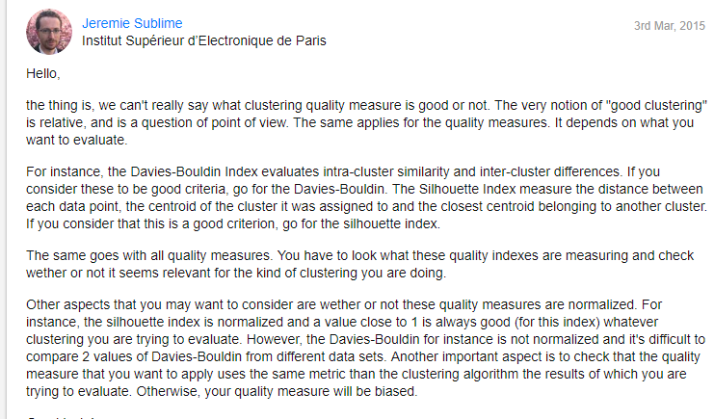

<https://stats.stackexchange.com/questions/11691/how-to-tell-if-data-is-clustered-enough-for-clustering-algorithms-to-produce-m>